**Global Terrorism Data Analysis**

Dataset: Global Terrorism Database (GTD)

Introduction:

Terrorism remains a critical global security issue. This project analyzes attack patterns, geographical hotspots, and trends over time. Students will perform exploratory data analysis (EDA) to uncover insights into terrorist activities worldwide.

**Objectives**

1. Which countries experience the highest number of terrorist attacks?

2. What are the most common types of terrorist attacks (bombings, armed assaults, etc.)?

3. Is terrorism increasing or decreasing over the years?

4. Which terrorist organizations are the most active?

5. Are there any seasonal trends in terrorist attacks?

**Analysis**

Step 1: Data Preprocessing

1. Import necessary libraries (Pandas, NumPy, Matplotlib, Seaborn).

2. Load the dataset.

3. Handle missing values (if any).

4. Convert date column to datetime format.

Step 2: Country-Level Analysis

1. Calculate the number of terrorist attacks by country.

2. Visualize top countries using bar charts or maps.

Step 3: Attack Type Analysis

1. Calculate the frequency of each attack type (bombings, armed assaults, etc.).

2. Visualize using pie charts or bar charts.

Step 4: Trend Analysis

1. Calculate the number of terrorist attacks over time (yearly/monthly).

2. Visualize using line plots to identify trends.

Step 5: Terrorist Organization Analysis

1. Identify the most active terrorist organizations.

2. Visualize using bar charts or heatmaps

Step 6: Seasonal Trend Analysis

1. Calculate the frequency of terrorist attacks by month or season.

2. Visualize using bar charts or seasonal decomposition plots.

**Visualization**

**Visualize Attack Trends**

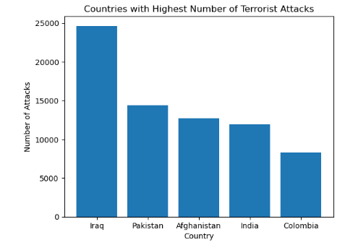 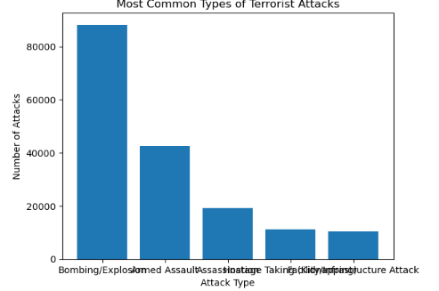

1. Countries with Highest Number of Terrorist Attacks

* Iraq, Pakistan, Afghanistan, India, and Nigeria are among the countries with the highest number of terrorist attacks.

1. Most Common Types of Terrorist Attacks

* Bombings, armed assaults, and assassinations are among the most common types of terrorist attacks.

1. Trend of Terrorist Attacks Over the Years 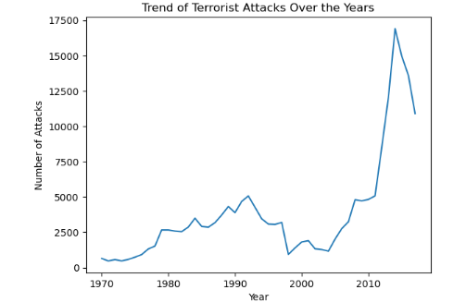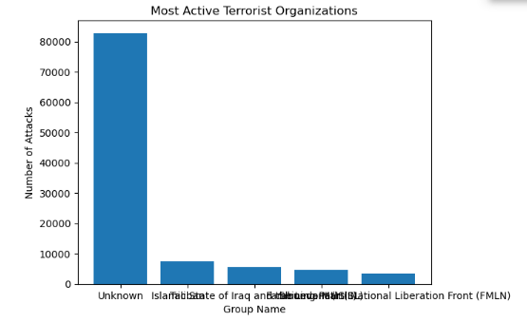

## 

## The analysis reveals that Boko Haram's top targets in Nigeria include

1. Private Citizens & Property: Frequent attacks on civilians aim to instill fear and disrupt daily life.
2. Military: Targeting military personnel and installations weakens the government's security apparatus.
3. Police: Attacks on police forces undermine law enforcement and governance.
4. Government (General): Targeting government buildings, officials, and institutions challenges the authority of the Nigerian government.
5. Religious Figures/Institutions: Attacks may indicate sectarian tensions or attempts to impose the group's ideology.

**Conclusion**

The data suggests that Boko Haram's strategy involves targeting both security forces and civilians, aiming to destabilize the region and challenge the government's authority. To effectively counter this threat, the government may consider:

* Enhanced Security Measures: Strengthening security forces and intelligence gathering to prevent attacks on military, police, and government targets.
* Civilian Protection: Implementing measures to protect private citizens and property, potentially through community engagement and outreach programs.
* Countering Ideology: Developing strategies to counter Boko Haram's ideology and reduce recruitment, possibly through education and social programs.
* Regional Cooperation: Collaborating with regional partners to share intelligence and coordinate efforts to combat Boko Haram's activities. reframe well?